OfficeSuite GoKinetic Standard User Portal Training

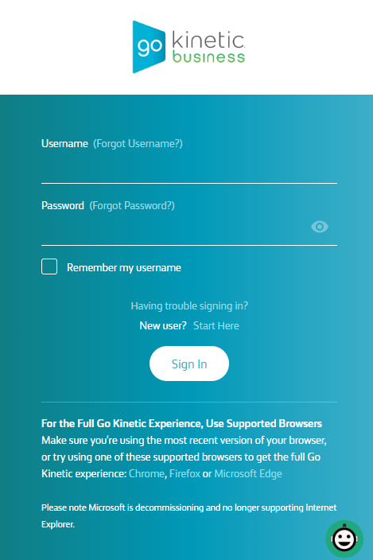
- Web Portal Access
    - Login to https://mybusiness.gokinetic.com
    - You will receive a Welcome email that contains instructions to access your web portal
    - The email subject line will read “Complete Your Go Kinetic Business Account Setup”.”
      - Your username is typically your email address.
      - You will create your portal passcode from the Welcome email referenced above
        - If you forget your passcode, click on “Having Trouble signing in” to reset your passcode.

  - Dashboard
Your Dashboard can be modified to contain the tiles you use most. (Click Add Widgets)

  - Individual User Settings
    - Click Services then My Services from the menu at the top
        - My Call Handling
          - Call Forwarding (Immediate)
          - Do Not Disturb
          - Call Waiting Tone
          - Selective Call Routing
          - Call Forwarding (No Answer Call Coverage)
            - Default should be set to 4 rings then forward to voicemail
        - My Call Groups
          - Lists the Call Groups that you are a member.
        - My Extensions
          - Modify your directory first and last name.
          - Enable or disable features (voicemail, multi-desking, call twinning etc…)
          - Change your Extension PIN (if your desk phone is logged out)
          - Change your Voicemail PIN
          - Set your Outbound Caller ID
            - This needs to show a number instead of “Site” if using a softphone.
          - Program phone keys
            - Change the programmable buttons on your desk phone.
Click the key you want to program (a new window will open)

- To Program a One Touch Speed Dial
  - Feature: Select One Touch Speed Dial
  - Label: Type the description you want to display on your phone label
  - Details: Enter 9 & the 10-digit phone number
- To Program a Monitor Key
        - Feature: Select Monitor Phone
        - Label: Type the description you want to display on your phone label
        - Details: Select the User that you will monitor
** Before programming a Monitor Key, follow these steps**
      - Click Call Monitor Group (step 10 below)
      - Select the Monitor or Answer key for each user to be monitored
      - Save
          - Set your Music on Hold
            - User level MOH can be different than Company-wide MOH setting.
          - Record your Directory Name
            - Your name must be recorded if using a dial by name directory.
          - Call Handling (same link as above)
          - Call Monitor Group
            - Settings to allow your extension to monitor or answer other extensions.
          - Voicemail Settings
      - To setup Voicemail to Email
Sends an audio file of the voicemail message to your email inbox
          - Check Enable Voicemail Notifications > Enter Notification Email
          - Notification Type = Audio File Only or Audio File with Transcript
Audio File Only sends the message as a .wav file.
Audio File w/ Transcript sends the .wav file & types out the msg.
          - Select “Delete voicemail from the system…” to suppress the vmail indicator light on your phone.
          - Click SAVE

      - To setup Zero out option from Voicemail Box
Each mailbox has the option of forwarding the caller to an alternate number when the caller presses “0” before hearing the tone to leave a message. If the caller presses 0, they will be transferred to the destination programmed below. If the caller does nothing, they will be given the option to leave a message.
          - Select box for Enable Dial Zero
          - Select My Coworker, Call Group or Auto Attendant
          - Use Drop-Down Menu beside your selected option to pick the destination.
          - Click SAVE

        - My Phones
        - Displays your programmable phone keys.
*See program phone keys above for instructions
        - You can also configure your ring tone.
        - My Voicemail Settings
*Same page as #11 above

- Help & Trouble Reporting
  - Open a Phone Related Trouble Ticket from your Go Kinetic Portal
    - Open a New Trouble Ticket
      - Click Support > Service Ticket Requests
      - Click Create New Service Ticket Request
      - Complete sections 1-4
      - Click Submit
    - Check Status of existing Service Ticket Request
      - Click Support > Service Ticket Requests
      - Click the arrow on the desired trouble ticket to see status.
    - Escalate an open Service Ticket Request (appears 1 hr after opening a ticket)
      - Click Support > Service Ticket Requests
      - Click the arrow on the desired trouble ticket.
      - Escalate option will be on the top right side of the ticket.
      - Enter notes in Escalate pop up and submit.

  - To report OfficeSuite phone related issues or Windstream Internet Trouble
      - Call 833.241.0100

